group policies and procedures

clinical governance policy

Category | Clinical Governance
Author | Castleman Healthcare Ltd
Responsible Director | Dominic Hennessey
Date of issue | September 2016
Next review date | July 2017
Document ref & version | Clinical Governance Policy 2016 sept
Related policies and guidance
- Corporate governance policy
Document revision and approval history
Version | Date | Author | Approved by | Comments
V1 | July 2016 | DH
V2 | Sept 2016
 | April 18 |  |  | Reviewed by JL

Overview and clinical governance operating model
Castleman Healthcare Ltd. is committed to Dorset CCG’s vision of “Supporting people in Dorset to lead healthier lives”. In order to do so, we are committed to tender for and provide the right service, by the right person or people, at the right time, and undertake continuous service improvement. We aim to be healthcare leaders. The Healthcare Leadership Model (Figure 1) outlines and clarifies our core values in clinical governance. In particular, our Clinical Governance structures and policies must Lead with Care, Evaluate Information, whilst Developing Capability and Holding to Account ourselves, our membership and shareholders, and our working relationships with our strategic partners. Castleman recognise that within our current scope, there is potential for us to provide services directly, i.e. by employing our own staff, or by contracting on behalf of our shareholders and constituent practices. In order to provide some services, we must also leverage resources external to our own, by inviting strategic partners to work with us. Castleman recognise these different operating models require different clinical governance structures and assurance frameworks. The aim in our operating models is to mirror the Healthcare Leadership Model dimensions of inspiring shared purpose, holding to account, sharing the vision and connecting our service.
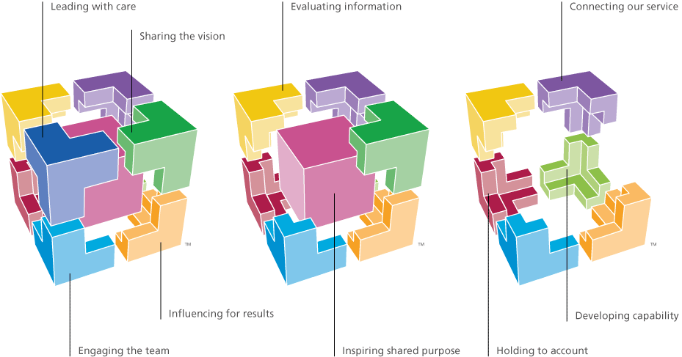
Figure 1: Healthcare Leadership Model

Services directly provided by Castleman Healthcare Ltd.
Figure 2 outlines the chain of responsibility for clinical governance, where services are provided directly by Castleman Healthcare Ltd.

Figure 2: Directly provided services chain of responsibility

Services indirectly provided by Castleman Healthcare Ltd. by member practices
Figure 3 outlines the chain of responsibility where member practices provide services on behalf of Castleman Healthcare Ltd. The vehicle we will use to ensure our governance structures are being adhered to would be a signed statement by the shareholder on behalf of the practice, or their authorised deputy. Castleman Healthcare would retain the right, as the primary contractor, to audit adherence with our policies and procedures.
Shareholder/ member practice responsibility
Castleman
Healthcare
Ltd.
responsibility
Figure 3: Member practice provided chain of responsibility

Services provided in partnership with other organisations and strategic partners
We recognise we may possess business or patient service competences that other organisations may not, and vice versa. We recognise and encourage the best way to provide services on behalf of our commissioners might be to work with strategic partners. In order to be fit to provide services, such collaborative working may be essential. Although as joint signatories for such service provision, we would have no direct control over our strategic partner’s internal governance structures, Castleman Healthcare Ltd. will limit our Clinical Governance risks by the most appropriate vehicle to the service specification. This might, and not exhaustively, be effected by a memorandum of understanding, a formal joint venture arrangement with formal delineation of areas of responsibility, a specific clinical governance policy to the service provided, or a ’shared balanced risk’ approach, with clear dialogue and openness in lines of communication: See Figure 4
Castleman Healthcare Ltd. responsibility
Strategic partner responsibility
Service Commissioners
Service Delivery
Dialogue

Figure 4: Partnership with other organisations chain of responsibility

Clinical Governance framework
Figure 5 shows our clinical governance framework.

Figure 5: Clinical Governance Framework

Right People: Competences, Education and Training
Castleman Healthcare Ltd. will ensure that people undertaking work on our behalf will have the necessary skills, training and availability to do so competently and safely. This is best achieved by competency mapping from the service specification to core competences, and from core competences selecting the best person or people to perform that role. In the event of there being competency gaps, Castleman will undertake to either recruit the resources needed to bridge the gap, or train existing people within our organisation to the required standard. We recognise that we strive to improve services, demonstrating competence and fitness for purpose is an iterative cycle. For example, patient feedback might inform service redesign, or a significant event might trigger a review of our service provision. We would support further training and educational needs identified in such cases. An outline of this process is in Figure 3.

Figure 6: Ensuring Competence
If a service has been tendered for on behalf of our shareholders, and their practices, Castleman also delegates responsibility for ensuring competence to provide that service to the practice lead for Clinical Governance.
The ‘Right People’ component of our Clinical Governance framework links back to the Healthcare Leadership Model dimensions of: Leading with care, sharing the vision, developing capability and engaging the team.

Risk Management
Risk is endemic in clinical practice, and in business. What might be considered ‘acceptable’ risk in business clinical practice, in understandably risk averse clinical practice might be less so. Consider the impact of a ‘missed’ email in a business environment: Although consequences might be serious in terms of reputation, finance or strategic, it is unlikely that a person is likely to come to significant harm if a business decision proves unwise. Consider likewise a ‘missed blood test’: The consequences of missing a grossly abnormal blood test potentially could be catastrophic. Castleman Healthcare Ltd. must be risk tolerant in terms of business and strategy, and risk averse and intolerant in terms of clinical service delivery, and as an organisation intelligent in understanding these two risks are not always mutually exclusive and may be interdependent.
For the purposes of Clinical Governance, Risk Management is not limited to Clinical Risk Management: Our scope should also aim to assess risk in our business processes, and eliminate or mitigate those risks where possible, whilst intending on not stifling innovation.
Our Risk Management Cycle, based on the WHO curriculum statement from their patient safety programme: ‘Understanding and Managing Clinical Risk’ is outlined in Figure 7.
For every clinical service we undertake, we will aim to IDENTIFY any risk, ASSESS the risk using an appropriate risk assessment tool, and where we have done so MITIGATE the risk where eliminating the risk involved entirely is not possible. Where possible, we shall aim to MEASURE the reduction in risk to inform subsequent iterations of the risk management cycle.

Figure 7: Castleman Healthcare Ltd. Risk Management Cycle

Our risk management cycle aims to address the leading with care, influencing for results, and evaluating information dimensions of the Healthcare Leadership Model.

Patient involvement and feedback
As an organisation constituted of shareholders from member General Practices, and in turn their core business to provide high quality patient care, our service design, delivery and evaluation should involve our most important stakeholders, our service users, wherever possible.
We are aware, however, that we are a commercial entity; patient consultation should not limit our ability to be agile where timelines are short: Where we see opportunity to act to provide quality clinical services for our patients within a short time line, as a clinically led organisation we should allow our understanding of our patients needs as our patients advocate to guide both our decision-making processes and our service design.
Castleman Healthcare Ltd. aims to be concordant with NHS England’s ‘House of Care’ approach (Figure 7) in acting in partnership with service users and their carers to deliver person centred coordinated care.
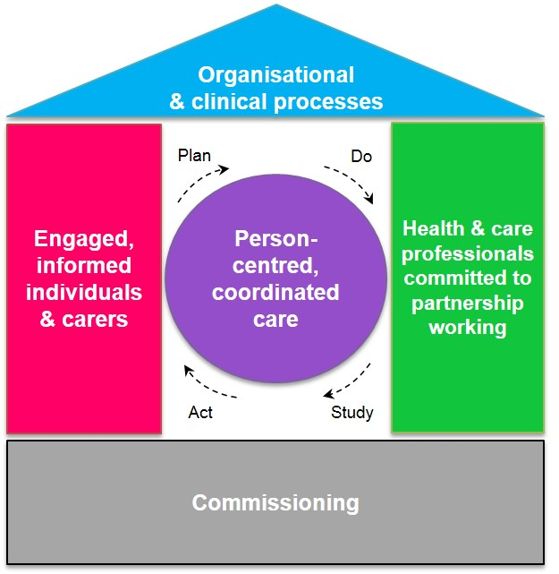
Figure 8: NHS England 'House of Care' Approach
Patient involvement at the ‘Planning’ stage of the central iterative process might constitute consultation exercises, patient representation at steering groups, polling of suggestions from current service users. We would then model our service delivery around our shared vision (the ‘Do’ part of the cycle). We would ‘Study’ the effect of our service where commissioned both through internal audit, feedback from our service users both immediate and formal. This might include immediate feedback from service users, patient satisfaction questionnaires or focus groups with the intention to Act to improve on our next iteration of the service cycle and re-plan.
Our commitment to patient-centred coordinated care echoes the dimensions of the Healthcare Leadership Model of inspiring shared purpose, leading with care, sharing the vision, and influencing for results.

Openness and whistle-blowing
Castleman Healthcare Ltd. operates an ‘openness culture’: Practically, this means that we aim to be internally transparent in our approach and processes, in particular with our employees, member practices and strategic partners. We encourage and applaud honesty and fairness, and acknowledge that errors will occur. When they do, we must learn from them whilst not apportioning blame. One mechanism through which this can be effected, for example, is through Significant Event Reporting. We have a whistle-blowing policy, making it everyone’s responsibility when they see wrong being done to say or do something about it. Castleman Healthcare Ltd. is committed to supporting whistleblowers – we will offer a zero tolerance environment to those who bully or harass those raising a concern, and promise to investigate concerns diligently and without prejudice. Where this is not possible with internal resources, for example if a whistle is blown in regards to the activity of the board, Castleman Healthcare Ltd. will engage with independent individuals or organisations to ensure concerns are investigated promptly and impartially.
Underpinning our openness culture and whistle-blowing policy is the dimension of the Healthcare Leadership Model of holding to account ourselves as an organisation, board, or the activities or services we provide.

Clinical and Service Audit
As NHS England commissions its National Clinical Audit and Patient Outcomes Programme (NCAPOP) through the Healthcare Quality Improvement Partnership (HQIP), Castleman Healthcare Ltd. has elected to use HQIP’s audit cycle as a basis for clinical audit, Figure 9.
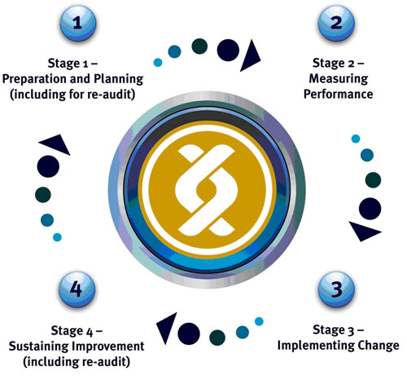
Figure 9: Healthcare Quality Improvement Partnership Audit Cycle
Castleman Healthcare Ltd. commits to undertaking clinical and service audit where directed by the commissioners of our services, and as a condition of our member practices and strategic partners providing services on our behalf or in conjunction with us, we would expect them to fully engage with the audit process.
Stage 1 of the audit cycle is identifying WHAT we are going to audit, WHY we are proposing to do so, ensuring the marker we are using is MEASURABLE, identifying WHOM we need to involve in the audit cycle and assure their engagement, whether this is ourselves, our member practices or stakeholders, or other stakeholders (should we be auditing patient outcome measures for example, we would need to engage the service users).
Stage 2 of the audit cycle, measuring performance must have a described METHOD, i.e. a protocol designed to outline timescales, methodology, ethical and confidentiality issues. It must also be MEANINGFUL, i.e. sampling an appropriate number of cases, aiming to cover all subgroups, e.g. race, sex, ages etc. It should be ROBUST i.e. data collection methods are validated, use pre-existing data sets for comparison, and partially complete or partially used or unused data needs to be explained (e.g. partial data from serial measurements excluded from final analyses).
Stage 3 should be ACTIONABLE, in that should measurement demonstrate either a need for improvement or that our performance exceeds that required but identify an area for improvement, the learning through the audit process needs to be translated in to a change in practice. Implementing a plan should have named individuals responsible for acting on each point of service improvement. The implementation should be communicated effectively to all stakeholders, and the deployment monitored against a timeline or goalposts to ensure it remains on target.
Stage 4 concerns re-audit where clinically appropriate or desirable for other reasons, and REFLECT on the prior audit cycle to inform the next cycle, and ensure any outstanding continuous improvement measures from the deployment plan continue to be acted on.
Our engagement in auditing our services maps on to the Healthcare Leadership Model dimensions of evaluating information, influencing for results and connecting our service.

Summary
Castleman Healthcare Ltd. aims to be a Leader in healthcare provision, and our clinical governance structures should reflect this in being well designed, well led, robust and transparent. We will affect our clinical governance leadership through our five-faceted clinical governance framework comprising the right people, risk management, patient involvement and feedback, openness and whistle-blowing which is endemic to our culture, and we will engage in clinical and service audit because it is the right thing to do.
Ensuring our relationships with our membership and shareholders, strategic partners and other stakeholders are open, honest and transparent underpins all we do. As healthcare leaders, we commit ourselves to sharing best practice, and ensuring our clinical governance structures are fit for purpose, and strive to encapsulate the dimensions of the Healthcare Leadership Model.

Bibliography
“HQIP-Criteria and Indicators of Best Practice in Clinical Audit-March 2012.pdf.” Accessed May 19, 2016. http://www.hqip.org.uk/public/cms/253/625/19/186/HQIP-Criteria%20and%20indicators%20of%20best%20practice%20in%20clinical%20audit-March%202012.pdf?realName=JlO6ff.pdf.
“NHS England » House of Care Model – Background.” Accessed May 18, 2016. https://www.england.nhs.uk/resources/resources-for-ccgs/out-frwrk/dom-2/house-of-care/house-care-mod/.
“ NHS Leadership Academy - Healthcare Leadership Model: The nine dimensions of leadership behaviour” Accessed May 19, 2016. http://www.leadershipacademy.nhs.uk/wp-content/uploads/dlm_uploads/2014/10/NHSLeadership-LeadershipModel-colour.pdf.
“WHO patient safety education curriculum: Topic 6: Understanding and managing clinical risk” Accessed May 19, 2016. http://www.who.int/patientsafety/education/curriculum/who_mc_topic-6.pdf.

