group policies and procedures

Patient restrictions

Category | Corporate Governance
Author | James Leyland
Responsible Director | Dr Dominic Hennessey
Date of issue | April 2019
Next review date | September 2023
Document ref & version | JL 1.1 - September 2021
Related policies and guidance
- Confidentiality Policy
- Information Governance Policy
- Data Protection Policy
Document revision and approval history
Version | Date | Author | Approved by | Comments
1.1 | April 19 | JL
 | Aug 19 |  |  | Reviewed JL
 | Sept 21 |  |  | Reviewed JL

Policy
It is the responsibility of Castleman Healthcare Ltd, its employees, attached staff, staff working for Castleman but employed by a member practice or Trust (henceforth called “the staff member”) to identify, determine and protect oral or written information which is regarded as confidential.
Castleman, being an organisation which covers a population of 120,000 and having shared staff across multiple practices and locations will, from time to time, find its staff members working from the practice or location where family members or friends are registered. Staff members, the practices, the Trusts and Castleman have a responsibility to ensure that the confidentiality of said family and friends is maintained and that the staff members in question are never in a situation where they have to treat family or friends or come into contact with their family or friends’ confidential information.

RESPONSIBILIties OF THE STAFF MEMBER
All staff must understand their responsibilities regarding confidential information and be vigilant for breaches, or potential breaches, of the security of information written or otherwise.
Confidentiality awareness training is the responsibility of Castleman Healthcare Ltd, or the employing organisation if not Castleman and forms a part of the induction of new staff and should be undertaken on an ongoing basis at staff meetings.
Managers are also responsible for monitoring compliance with this policy and for taking appropriate action in the event of a breach which will lead to disciplinary action.
Where staff are aware that they are working from a practice where their family or friends are registered they must disclose this information to the Practice Manager of each practice at the earliest opportunity.
The staff will sign the attached document (Appendix A) which gives assurances that in no circumstances will they see, treat or access the records of their family member of friends. A breach of this assurance will result in disciplinary proceedings.

responsibilities of the practice
Castleman is aware that some practices in its network may have in place policies where the family of its own staff members cannot be registered at the practice. However, with shared staff, it would be impractical to apply this policy. Staff may well be working across twelve GP practices and this will severely limit the choice of the family member has in accessing a GP practice.
Instead, these staff should be given special status to carry out their duties whilst their family members remain registered.
The practice should ensure however that the staff member is never expected to see, treat, visit etc. the family member or friend under any circumstances.
The Practice should instigate the following on the SystmOne clinical system to restrict access to the records of those people disclosed by the staff member.

Systmone instructions
Restricting a patient record
- Search for the patient and open their record

- Along the Tree go to the administrative tab

- Then go to

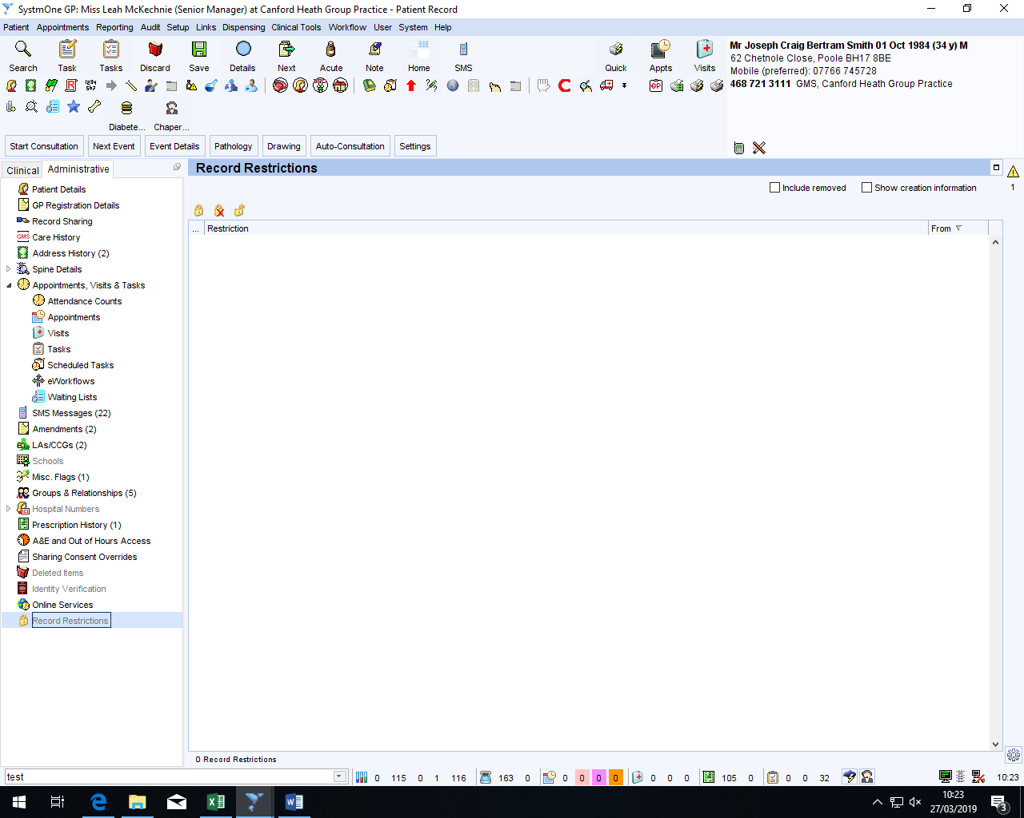
If the patient already has restrictions, they will be listed in the white box
- To record a new restriction, click on the padlock icon

- It will then pop-up with the “Add Record Restriction” box:

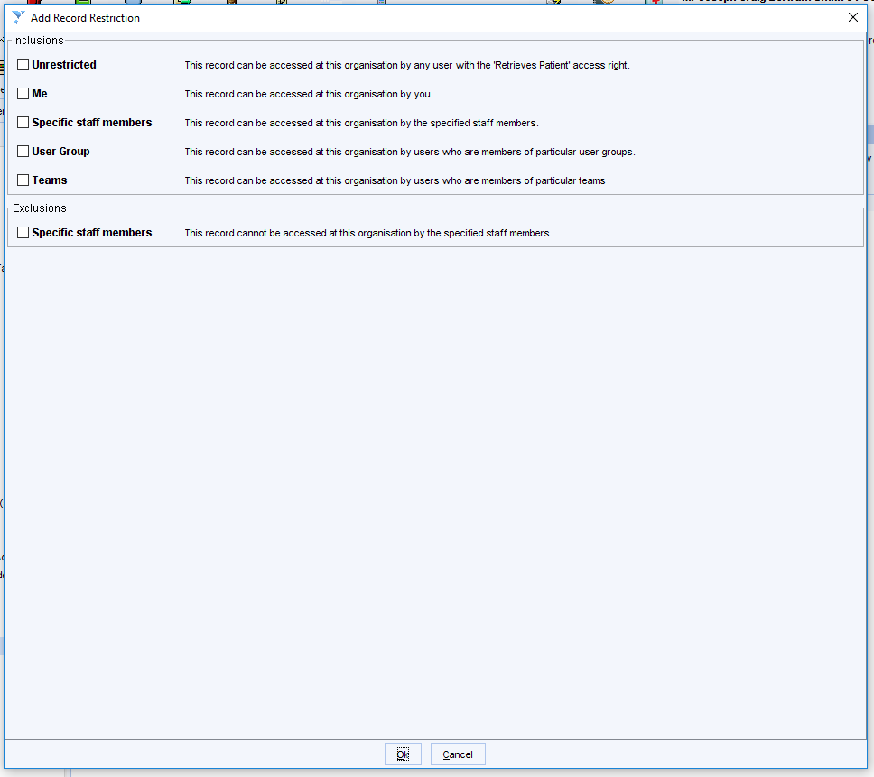

Inclusions: Specific staff members: You can set the staff members that can access that patients record. When you tick the box, it will drop down another box for you to add the staff members:

Inclusions: User Group: You can set specific user groups to be able to access the record. When you tick the box, it will drop down another box for you to add the user groups, you can add more than one user group.

Exclusions: Specific staff members: This option lets you set staff members that cannot access the patients record. When you tick the box, it will drop down another box for you to add the staff members:
Press “Ok” to save

To remove restrictions if needed:

If there are any restrictions, they will be listed in the white box

Click on restriction you want to remove and using the padlock symbols along the top, press the padlock with a cross to remove the selected restriction or the unlocked padlock to removal all restrictions.

Save the patient record to save any changes

responsbilities of castleman healthcare ltd.
Castleman will, as part of its induction programme, ensure all new staff working for a Castleman service are aware of this policy, its implications and ask them to complete the attached form in Appendix A. Castleman will support any practice who needs to instigate the disciplinary procedure.

Appendix a – disclosure form
NAME OF STAFF MEMBER:
POSITION:

To: The Practice Manager of: _____________________________ (Practice Name)
I disclose that I am aware that the follow patients are known to me as either family members or friends and therefore I understand that it is inappropriate for me to see, treat, or view the records of these patients and I understand that should I do so this is result in disciplinary proceedings against me.
Signed: ___________________________
Print: ____________________________
Date: ____________________________
Name of Patient | Date of Birth / Address | Relationship
I ______________________________________ (Practice Manager) confirm that the records of these patients have been restricted in accordance with this policy.
Signed_________________________________ (Practice Manager) Date: __________________
Please send a copy of this form to the Castleman email.

